**LAB#09**

**APPLIED PHYSICS**

**Submitted to: Mr. Muhammad Shoaib**

**Group Members**

**Tanzeela Asghar (2021-BSE-032)**

**Laraib Ijaz (2021-BSE-036)**

**Fizza Khan (2021-BSE-012)**

**Dated: February 20, 2022.**

**THEVENINS THEOREM**

**VERIFICATION:**

| **S.No** | **Source Voltage (Volt)** | **Measurements in Original Circuit** | | **Thevenin Voltage (Vth) Volt** | **Thevenin Resistance (Rth) ῼ** | **Measurements in Thevenins Equivalent Circuit** | |
| --- | --- | --- | --- | --- | --- | --- | --- |
|  |  | **V12**  **(Volt)** | **I12**  **(Amp.)** |  |  | **V12**  **(Volt)** | **I12**  **(Amp.)** |
|  |  |  |  |  |  |  |  |
| **1.** | **12** | **2.4** | **4.004m** | **6** | **500** | **2.4** | **4m** |
| **2.** | **5** | **1** | **1.67m** | **2.5** | **500** | **1** | **1.67m** |
| **3.** | **9** | **1.8** | **3m** | **4.5** | **500** | **1.8** | **3m** |

**Observation 01:**

Here the voltage is 12V with four resistors having resistances 1K ohm each. Using multi-meter the readings are as under.

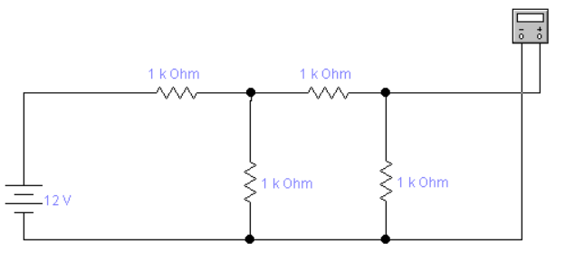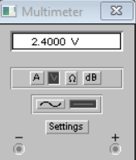

Here we have calculated the current having 12V with four resistors with 1K ohm each resistance.

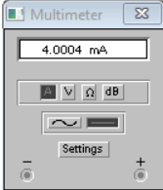

Now we have converted the circuit into 2 resistors and calculated the Thevenins Voltage.

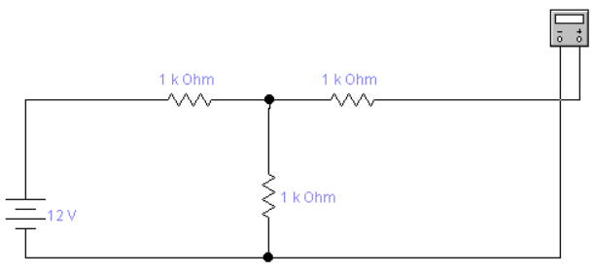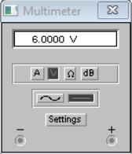

The AC source is removed and the value of Thevenins Resistance is calculated.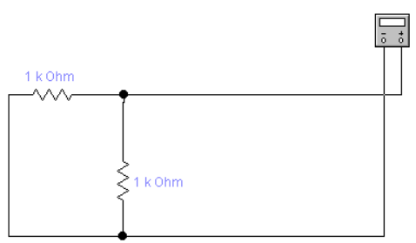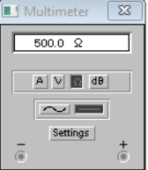

Here we have used Thevenins Voltage and Resistance to calculate Voltage in Equivalent Circuit.

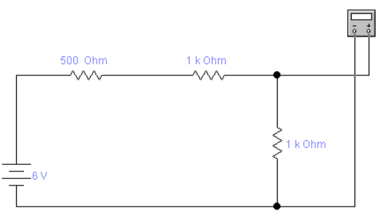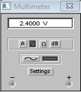

Here we have used Thevenins Voltage and Resistance to calculate Current in Equivalent Circuit.

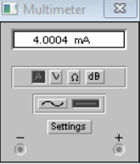

**Observation 02:**

Here the voltage is 5V with four resistors having resistances 1K ohm each. Using multi-meter the readings are as under

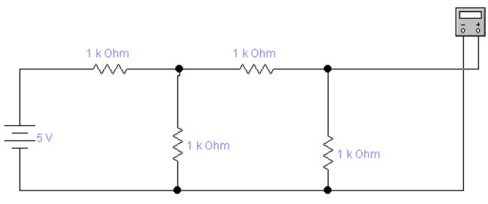 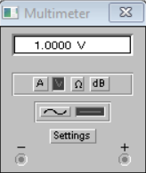

Here we have calculated the current having 5V with four resistors with 1K ohm each resistance.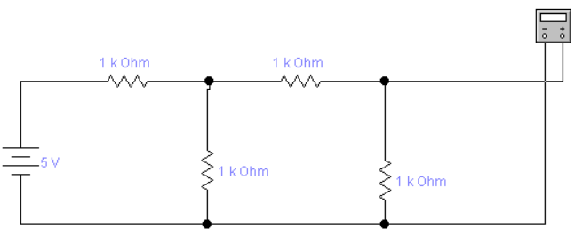

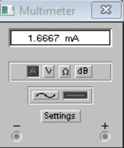

Now we have converted the circuit into 2 resistors and calculated the Thevenins Voltage.

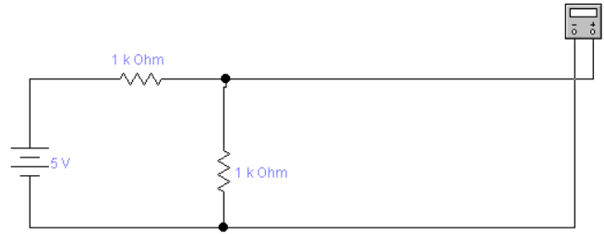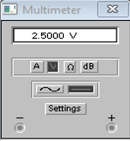

The AC source is removed and the value of Thevenins Resistance is calculated

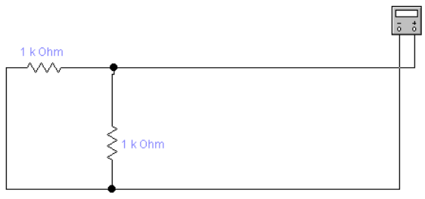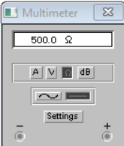

Here we have used Thevenins Voltage and Resistance to calculate Voltage in Equivalent Circuit.

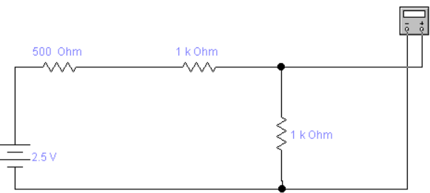

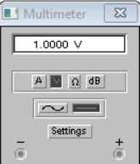

Here we have used Thevenins Voltage and Resistance to calculate Current in Equivalent Circuit.

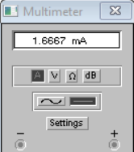

**Observation 03:**

Here the voltage is 9V with four resistors having resistances 1K ohm each. Using multi-meter the readings are as under:

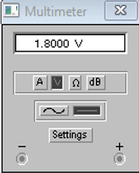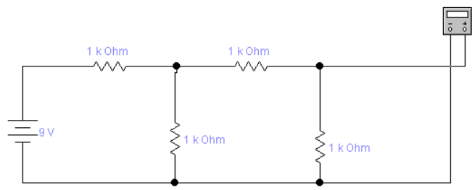

Here the voltage is 5V with four resistors having resistances 1K ohm each. Using multi-meter the readings are as under to find Current.

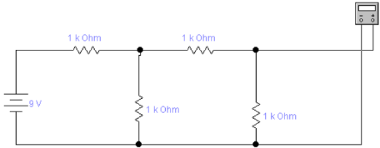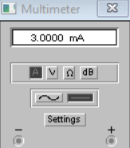

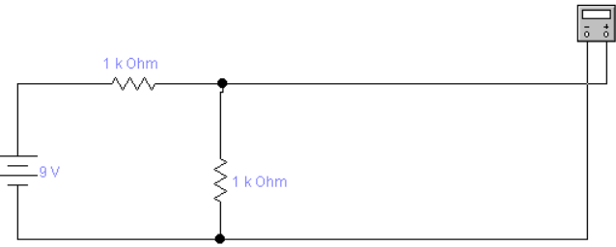

Now we have converted the circuit into 2 resistors and calculated the Thevenins Resistance.



Now we have converted the circuit into 2 resistors and calculated the Thevenins Voltage.

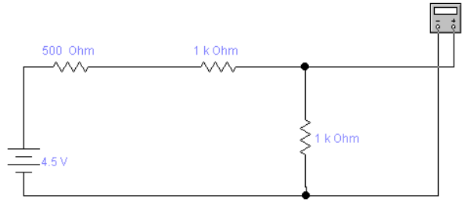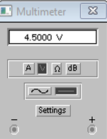

Here we have used Thevenins Voltage and Resistance to calculate Current in Equivalent Circuit.

